

**MINI PROJECT REPORT**

***Submitted by***

**NISHANTH SENTHILVASAGAM T**

**(710718104038)**

**YESHVANTH N**

**(710718104059)**

***in partial fulfillment for the award of the degree***

***of***

**BACHELOR OF ENGINEERING**

**in**

**COMPUTER SCIENCE AND ENGINEERING**

**DR. N.G.P. INSTITUTE OF TECHNOLOGY, COIMBATORE**

**ANNA UNIVERSITY: CHENNAI 600 025**

**OCTOBER 2019**

**ANNA UNIVERSITY : CHENNAI 600 025**



**SENSITIVITY OF WORDS**

**A PROJECT REPORT**

***Submitted by***

**NISHANTH SENTHILVASAGAM T**

**(710718104038)**

**YESHVANTH N**

**(710718104059)**

***in partial fulfillment for the award of the degree***

***of***

**BACHELOR OF ENGINEERING**

**in**

**COMPUTER SCIENCE AND ENGINEERING**

**DR. N.G.P. INSTITUTE OF TECHNOLOGY, COIMBATORE**

**ANNA UNIVERSITY: CHENNAI 600 025**

**OCTOBER 2019**

**ANNA UNIVERSITY : CHENNAI 600 025**

**BONAFIDE CERTIFICATE**

Certified that this project report “**SENSITIVITY OF WORDS**” is the bonafide work of “**NISHANTH SENTHILVASAGAM T,YESHVANTH N**” who carried out the project work under my supervision.

**Dr. S.V. Sudha Dr. S. Ayyasamy**

HEAD OF THE DEPARTMENT SUPERVISOR

Computer Science and Engineering Professor

Dr. N.G.P. Institute of Technology Computer Science and Engineering

Kalappati Main Road, Dr. N.G.P. Institute of Technology

Coimbatore-641048 Kalappati Main Road,

Coimbatore-641048

**Acknowledgement**

We express our extreme gratefulness to our most respected Head of the Department, **Dr.S.V.Sudha, M.E., Ph.D.,** for providing this valuable opportunity to us.

We also express our whole gratitude to our class advisor **Dr.S.Ayysamy, M.E., Ph.D**., for his constant suggestions, encouragement and valuable guidance in the preparation.

**TABLE OF CONTENTS**

* **ABSTRACT**
* **INTRODUCTION**
* **FLOW DIAGRAM**
* **SAMPLE CODE**
* **SAMPLE FILE**
* **APPLICATIONS**
* **CONCLUSION AND FUTURE RECOMMENDATIONS**
* **REFERENCE**

**ABSTRACT**

This project focuses on analysis sensitivity of words in a given data. The data is gathered in two forms:

1. Through user input blobs
2. Through user input file path

INPUT BLOBS:

User is prompt to enter the number of blobs required to know their respective sensitivity.

Number of blobs are gathered and stored in a file named “ textofblobs.txt ” and finally the sensitivity is shown in with respective blobs.

INPUT FILE PATH:

User is prompt to enter the file path.

Total sensitivity is calculated.

SENSITIVITY CALCULATION:

Sensitivity is calculated with the help of package imported from “ textblob” and “TextBlob” method is imported from it.

Positive, negative and neutral scores are calculated and this result is displayed as output.

**INTRODUCTION**

Sentiment analysis could be used to analyze or predict. It has seen a vast number of applications in recent time as 80% of data available is unstructured in the form of text, audios, videos etc.

I used sentiment analysis on text to compare subject with its sentiments, to find whether they are correlated or not.

Here is the step by step approach on how it was done:

Gathering data:

File or input text known as “blob” was used as a source of text in this project, we gathered using keywords.

Text cleaning:

Stopwords removal, punctuation removal, stemming etc.,were few of the techniques used to clean the text. This is common to every text analysis problem.

Sentiment generation:

It is then important to fine the sentiment of the statement, there are many smart and reliable algorithms out there to tag statements with complex or simple sentiments. Some sentiment algorithm would also give you sentiments like anxiety, sadness etc.,while the most commonly used are **positive, negative and neutral**. **Natural language processing** is used to tag each word with a sentiment and the overall score or sentiment that the statement would get depends on the underlying word sentiments.

In this project gathered data from file or text inputs are stored and sensitivity of words (i.e) sentimental analysis is done.

**FLOW DIAGRAM**

Opinion or review text

Split into

Sentences

Stemming & Cleaning

Bags of Words

Compare with

Opinion Lexicon

Scoring function

Sentiment Score

**SAMPLE CODE**

***Main program file:***

import os

from textblob import TextBlob

choice=0

print("******PYTHON PROJECT******")

print("SENSITIVITY OF WORDS")

while(choice!=3):

print("Your choice: \n\t 1)Enter sentence to calculate \n\t

2)Enter file name \n\t 3)To exit\n")

choice=int(input("Enter your choice"))

if(choice==1):

os.system('python *location_of_pytext_file')

if(choice==2):

os.system('python *location_of_pyfile_file')

print("Press any key to quit")

f=input()

quit

***pytext:***

import sys

import os

#os.system("python -m install textblob")

from textblob import TextBlob

fcount=int(input("Enter the number of feedbacks to analyse:"))

fp1=open('bloboftext.txt','w+')

for i in range(fcount):

fblob = input("Enter the blob: ")

fp1.write(fblob)

fp1.write("\n")

fp1.close()

fp2=open('bloboftext.txt','r')

for fblob in fp2:

rblob=(TextBlob(fblob)).sentiment.polarity

print("sentiment of",fblob,"=",rblob)

fp2.close()

print("Press any key to exit")

f=input()

***pyfile:***

from textblob import TextBlob

pos_correct=0

neg_correct=0

nut_correct=0

total=0

with open("*location_of_blobfile_txt_file","r") as f:

for line in f.read().split('\n'):

analysis = TextBlob(line)

if analysis.sentiment.polarity > 0:

pos_correct += 1

total +=1

with open("location_of_blobfile_txt_file ","r") as f:

for line in f.read().split('\n'):

analysis = TextBlob(line)

if analysis.sentiment.polarity < 0:

neg_correct += 1

total +=1

with open("location_of_blobfile_txt_file ","r") as f:

for line in f.read().split('\n'):

analysis = TextBlob(line)

if analysis.sentiment.polarity == 0:

nut_correct += 1

total +=1

print("result: +ve( ;) ) = ",pos_correct/total,"-ve( ;( ) = ",neg_correct/total,"nutral ( :| ) = ",nut_correct/total)

print("Press any key to exit")

f=input()

**SAMPLE FILE**

***Bloboftext.txt:***

i am very happy

it was very touching

it was very pathetic

exciting movie

thrilling horror

love action drama

***Blobfile.txt:***

best

special

okay

no

none good

good

okay

no

not

good

worst

the movie was best one I have ever seen.

**SAMPLE OUTPUT**

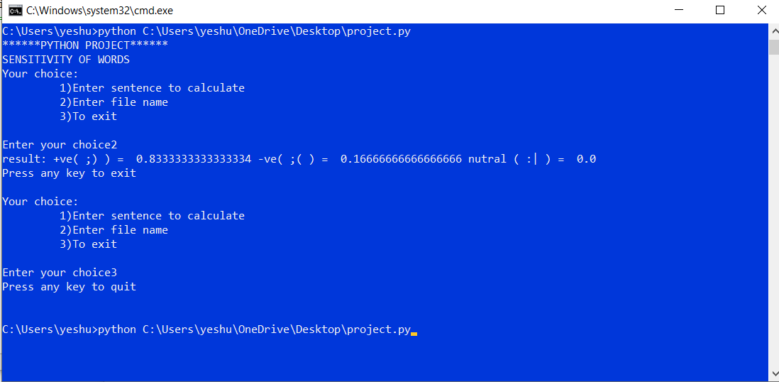

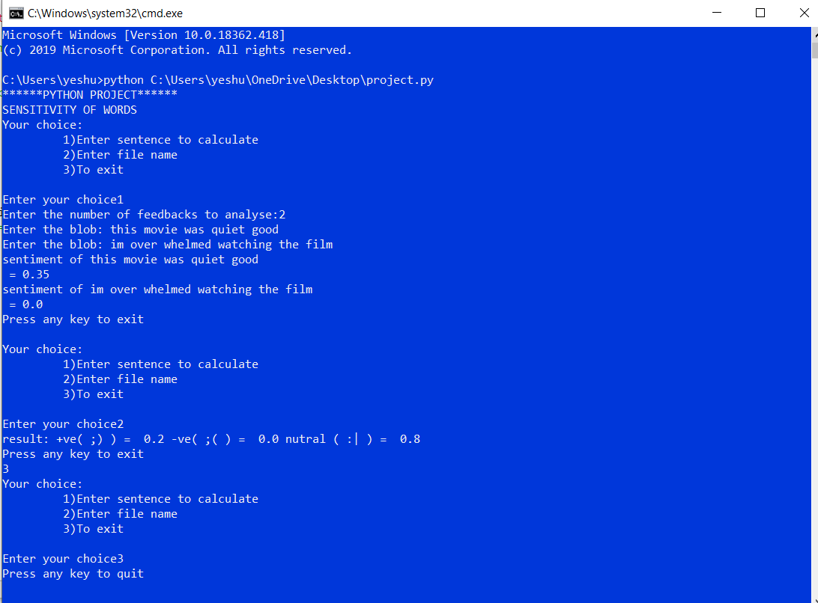

**APPLICATIONS**

1. Computing customer satisfaction metrics

You can get an idea of how happy customers are with your products from the ratio of positive to negative tweets about them.

2. Identifying detractors and promoters

It can be used for customer service, by spotting dissatisfaction or problems with products.

3. Identify the thoughts and to rate them

It can be used to rate the text sent by a person with the subjectivity and object conveyed.

**CONCLUSION AND FUTURE RECOMMENDATIONS**

Analysis of text based on lexicons are accurate to some extent and the use of machine learning along with deep learning improves the ability to predict and analyse.

Lexicons library contains only set of predefined keys or keywords and with the help of machine learning and deep learning and including them in lexicons enable the analysis more accurate.

Twitter API can be used to gather data related to any specific event which can also be included.

Sensitivity of words refers sense to words that is when a word is capitalized, first word is lower in case, any other non-dictionary words are used its sensitivity differs from normal text which differentiate the words uniquely.

**REFERENCE**

[1]Nandha Info Tech.

<https://github.com/changhuixu/sentiment-analysis-using-python>

Project idea.

[2]edureka!

<https://www.youtube.com/watch?v=O_B7XLfx0ic>

Code Sample.

[3]sentdex

<https://pythonprogramming.net/sentiment-analysis-python-textblob-vader/>